**Commodore C64: Diag64cart Rev. 0**

**Module Description**

Table of Contents

Introduction 1

Select Switches 1

Configuration with solder bridges 2

Example configurations 3

EPROM Type 27C512 3

EPROM Type 27C256 3

EPROM Type 27C128 3

EPROM Type 27C64 3

C64 and C128 Diagnostic Cartridge 3

C128 Cartridge Only 3

C64 Diagnostic Cartridge Only 3

Switches 3

EPROMs 4

Using parallel EEPROMs 5

Dimensions 5

Suggested Software 8

Revision History 8

Rev. 0 8

# Introduction

The Diag64cart is a C64/C128 cartridge PCB, that is especially made for the need of diagnostic software, like Dead Test Rev. 781220 and Diagnostic Rev. 586220. The Diag64cart is derived from the Versa64cart (<https://github.com/bwack/Versa64Cart>), it lacks of the ability to be a 16k cartridge, though.

The geometry of this cart was especially made for the cheap [Maszczyk](https://www.maszczyk.pl/en.html) KM-20 and the [Kradex](https://www.kradex.de/) Z7 cartridge cases. Those are available from <https://restore-store.de/> or <https://www.tme.eu>.

Dead Test and Diagnostic reside in two different address spaces of the C64. Also, they are differently configured via or and use different chip select signals ( or ).

# Select Switches

While Dead Test replaces the Kernal, Diagnostic is an 8k auto-start cartridge at address $8000. Diag64cart has a fix assignment of EPROM offset addresses (via A13) and the cartridge type, which is done by the left DTDP switch SW1.

The right switch (SW2) only switches the EPROM offset address A14. This results in four possible software banks in the EPROM. The use of 27C256 or 27C512 is recommended.

The switches are a cheap, simple and comfortable way to reconfigure the cartridge for the different diagnostic tools. The configuration of the cartridge can be modified with solder bridges.

|  |  |  |  |  |  |  |  |  |
| --- | --- | --- | --- | --- | --- | --- | --- | --- |
| SW1 | SW2 |  |  | Chip Select | A13 | A14 | Type | EPROM |
| down | down | HIGH | LOW |  | LOW | LOW | Diagnostic | $0000 |
| up | down | LOW | HIGH |  | HIGH | LOW | Dead Test | $2000 |
| down | up | HIGH | LOW |  | LOW | HIGH | Diagnostic | $4000 |
| up | up | LOW | HIGH |  | HIGH | HIGH | Dead Test | $6000 |

Table 1: Default Configuration: assignment of switches and software type

The connection between SW1, , , chip select and A13 implies an order of the type of software/cartridge in the EPROM memory.

**Do not confuse** the EPROM offset address with the memory address of the cartridge in the C64/C128. A selected cartridge will appear in the computer’s address, that is specified by the chip select (that is $8000 for and $C000 for ). The EPROM offset address is the address in the programming buffer/EPROM, where the binaries reside.

# Configuration with solder bridges

The default configuration is described in the previous chapter. This can be modified with solder bridges.

E.G. the C128 works differently than the C64. If the C128 finds either or LOW, it will boot into the C64 mode. For a C128 cartridge, both signals have to be high.

|  |  |  |  |
| --- | --- | --- | --- |
| Solder bridge | Default | When closed | Note |
| JP1 | closed | Chip select () switched by SW1 | If JP2 is closed, open JP1 |
| JP2 | open | Chip select always | e.g. for only diagnostic software or C128 mode only |
| JP3 | closed | switched by SW1,  A13 = | Open for permanent settings for |
| JP4 | closed | switched by SW1 | Open for permanent settings for |
| JP5 | open | always LOW | e.g. for C64 diagnostic only |
| JP6 | open | A14 always LOW | In case only two software required and A14 not installed |
| JP7 | open | A15 always LOW | Close for EPROM type 27C512 |

Table 2: Configuration of the solder bridges

# Example configurations

## EPROM Type 27C512

If a 27C512 is used, it might be desired to program the EPROM starting at offset address $0000. For this purpose, A15 has to be LOW. This **requires JP7 to be closed**.

## EPROM Type 27C256

This is the default EPROM type**. No modifications are required**. JP7 is open be default, that means A15 is HIGH (that is the VPP input on a 27C256).

## EPROM Type 27C128

This 16k EPROM can hold two 8k software. In this case, SW2 (which switches A14 between LOW and HIGH =open, due to the pull-up resistor). In a 27C128, this pin is /PGM, which should be HIGH. The switch **SW2 can just be omitted**, no further modification required, since the pull-up resistor R3 does the job.

## EPROM Type 27C64

This is actually an abuse, since a 27C64 can only hold 8k of software. So, no switch is required at all. A13 (Pin 26) is a “not connected” pin of the EPROM. The pull-up R4 can stay. It does not harm the function of the EPROM, but it is not required. In case the cartridge software resides in $8000, close JP2 and JP5. An 8k cartridge at $C000 can be achieved by bridging the solder pads of SW1 to mimic it in up position. The solder pads of the alternative switch SW4 might come in handy in this case.

## C64 and C128 Diagnostic Cartridge

The C128 requires both, and to be HIGH (=open) and the chip select () to be . For this purpose, **open JP4 and JP1 and close JP2**. While the 8k memory at $0000 and $4000 are reserved for C64 software and the 8k memory banks at $2000 and $6000 are reserved for C128 cartridge software.

## C128 Cartridge Only

Again, both , and , have to be HIGH (=open) and the chip select () has to be . For this purpose**, open JP1, JP3, JP4 and close JP2**.

## C64 Diagnostic Cartridge Only

In case it is desired to have all software reside at $8000, needs to be open, needs to be low and the chip select has to be . For this purpose, **open JP1, JP3 and JP4 and close JP2 and JP5**.

# Switches

The switches SW1 and SW2 are built in sideways. They are DPDT slide switches with a pin pitch of 4mm. The hole distance is 19mm (which is not important for this project, but just a part of the switches specification). The height of the switch body is 6.9mm. This is met be the reichelt.de part number T217 or the AliExpress SS22F25-G7, but obviously, there are more 199mm pitch panel mount switches, that meet these specifications.

Alternatively, there are footprints (SW4 and SW5) for the also wide spread AliExpress mini slide switches MSS22D18.

# EPROMs

Four different types/sizes of EPROMs can be used with the Versa64Cart, not all settings make sense with them. Their pin out is shown in Table 3.

The effect of the settings and the recommended configurations are shown in Table 4.

|  |  |  |  |  |  |  |  |  |  |  |  |
| --- | --- | --- | --- | --- | --- | --- | --- | --- | --- | --- | --- |
| 27C64 | | | | | | | | | | | |
|  | 27C128 | | | | | | | | | |  |
|  | 27C256 | | | | | | | |  |
|  | 27C512 | | | | | |  |
|  | SOCKET | | | |  |
| Vpp | Vpp | Vpp | A15 | 1 | A15 | VCC | 28 | VCC | VCC | VCC | VCC |
| A12 | A12 | A12 | A12 | 2 | A12 | A14 | 27 | A14 | A14 | /PGM | /PGM |
| A7 | A7 | A7 | A7 | 3 | A7 | A13 | 26 | A13 | A13 | A13 | n.c. |
| A6 | A6 | A6 | A6 | 4 | A6 | A8 | 25 | A8 | A8 | A8 | A8 |
| A5 | A5 | A5 | A5 | 5 | A5 | A9 | 24 | A9 | A9 | A9 | A9 |
| A4 | A4 | A4 | A4 | 6 | A4 | A11 | 23 | A11 | A11 | A11 | A11 |
| A3 | A3 | A3 | A3 | 7 | A3 | /OE | 22 | /G/Vpp | /G | /G | /G |
| A2 | A2 | A2 | A2 | 8 | A2 | A10 | 21 | A10 | A10 | A10 | A10 |
| A1 | A1 | A1 | A1 | 9 | A1 | GND | 20 | /E | /E | /E | /E |
| A0 | A0 | A0 | A0 | 10 | A0 | D7 | 19 | D7 | D7 | D7 | D7 |
| D0 | D0 | D0 | D0 | 11 | D0 | D6 | 18 | D6 | D6 | D6 | D6 |
| D1 | D1 | D1 | D1 | 12 | D1 | D5 | 17 | D5 | D5 | D5 | D5 |
| D2 | D2 | D2 | D2 | 13 | D2 | D4 | 16 | D4 | D4 | D4 | D4 |
| GND | GND | GND | GND | 14 | GND | D3 | 15 | D3 | D3 | D3 | D3 |

Table 3: EPROM pin compatibility

|  |  |  |  |  |  |
| --- | --- | --- | --- | --- | --- |
| EPROM | Size | A15 | A14 | A13 | 16k |
| 27C512 | 64kx8 | yes | yes | yes | yes |
| 27C256 | 32kx8 | HIGH | yes | yes | yes |
| 27C128 | 16kx8 | HIGH | HIGH | yes | yes |
| 27C64 | 8kx8 | HIGH | HIGH | HIGH | no |

Table 4: Settings per EPROM type

In case Vpp is located at a dedicated pin (pin 1), A15 has no effect anymore. A HIGH level is recommended (switch is off) . The /PGM Pin should be set HIGH. The n.c. (not connected) pin should be HIGH (with pull-up) or open. For an 8k EPROM, the 16k setting makes no sense.

# Using parallel EEPROMs

There are ***parallel*** EPROMs, which fit into the EPROM sockets. They do not require erasing with a UV eraser, like EPROMs, but the price is higher.

Since they can be written, which is controlled by the signal, but the Super Expander II cartridge is lacking of this functionality, this signal has to be HIGH (inactive). The 28C256 has the A14 signal connected to Pin 1, which is A15 of the EEPROM socket. This is no problem, but it has to be kept in mind, that the jumper for A15 has effect on the bank select A14 of the EPROM.

|  |  |  |  |  |  |  |  |
| --- | --- | --- | --- | --- | --- | --- | --- |
| 28C64 | | | | | | | |
|  | 28C256 | | | | | |  |
|  | SOCKET | | | |  |
| n.c. | 💣A14 | 1 | A15 | VCC | 28 | VCC | VCC |
| A12 | A12 | 2 | A12 | A14 | 27 | /WE | /WE |
| A7 | A7 | 3 | A7 | A13 | 26 | A13 | n.c |
| A6 | A6 | 4 | A6 | A8 | 25 | A8 | A8 |
| A5 | A5 | 5 | A5 | A9 | 24 | A9 | A9 |
| A4 | A4 | 6 | A4 | A11 | 23 | A11 | A11 |
| A3 | A3 | 7 | A3 | /OE | 22 | /G/Vpp | /OE |
| A2 | A2 | 8 | A2 | A10 | 21 | A10 | A10 |
| A1 | A1 | 9 | A1 | GND | 20 | /E | /CE |
| A0 | A0 | 10 | A0 | D7 | 19 | D7 | D7 |
| D0 | D0 | 11 | D0 | D6 | 18 | D6 | D6 |
| D1 | D1 | 12 | D1 | D5 | 17 | D5 | D5 |
| D2 | D2 | 13 | D2 | D4 | 16 | D4 | D4 |
| GND | GND | 14 | GND | D3 | 15 | D3 | D3 |

Table 5: EEPROM pin compatibility

|  |  |  |  |  |
| --- | --- | --- | --- | --- |
| EEPROM | Size | A15 | A14 | A13 |
| 28C256 | 32kx8 | =A14 | OPEN | yes |
| 28C64 | 8kx8 | OPEN | OPEN | OPEN |

Table 6: Settings per EEPROM type

# Dimensions

The dimensions are made to fit the said cartridge cases.

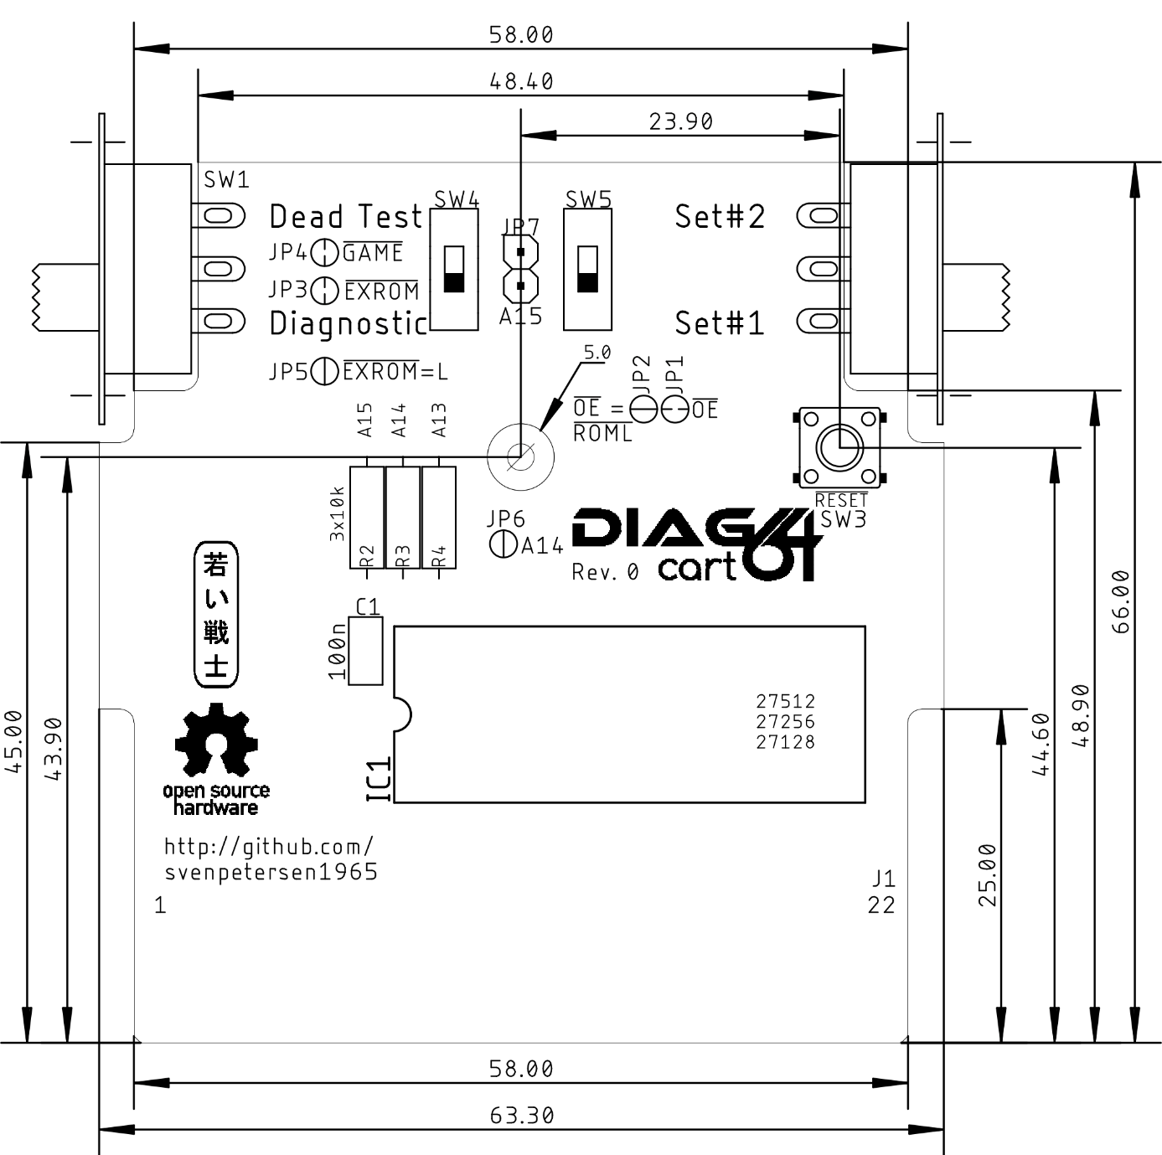

Figure 1: Dimensions

The Maszczyk KM-20 and the Kradex Z7 cartridge cases both fit the Diag64cart. The dimensions are slightly different, though.

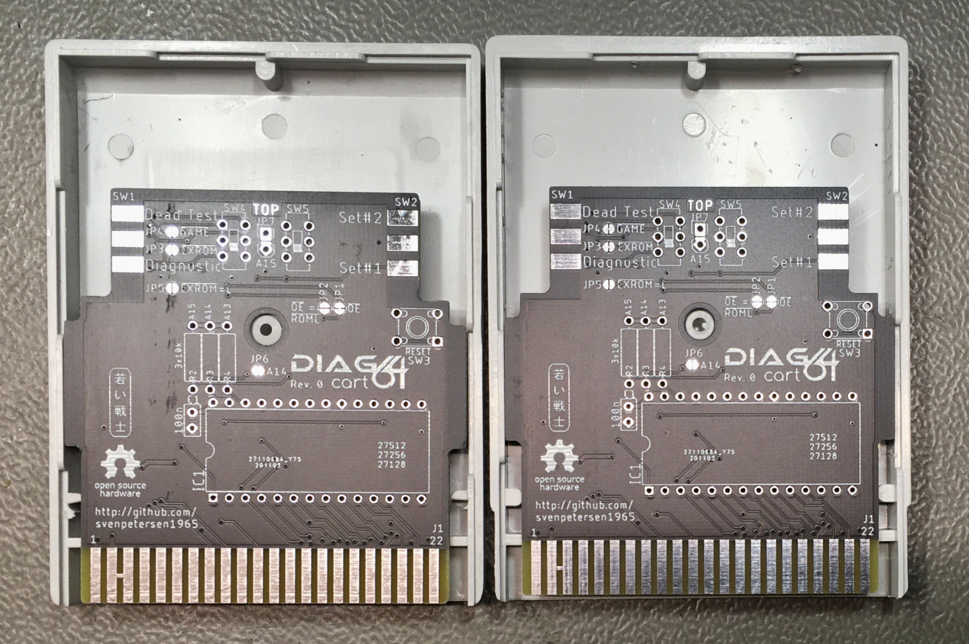

Figure 2: Maszczyk KM-20(left), Kradex Z7 (right)

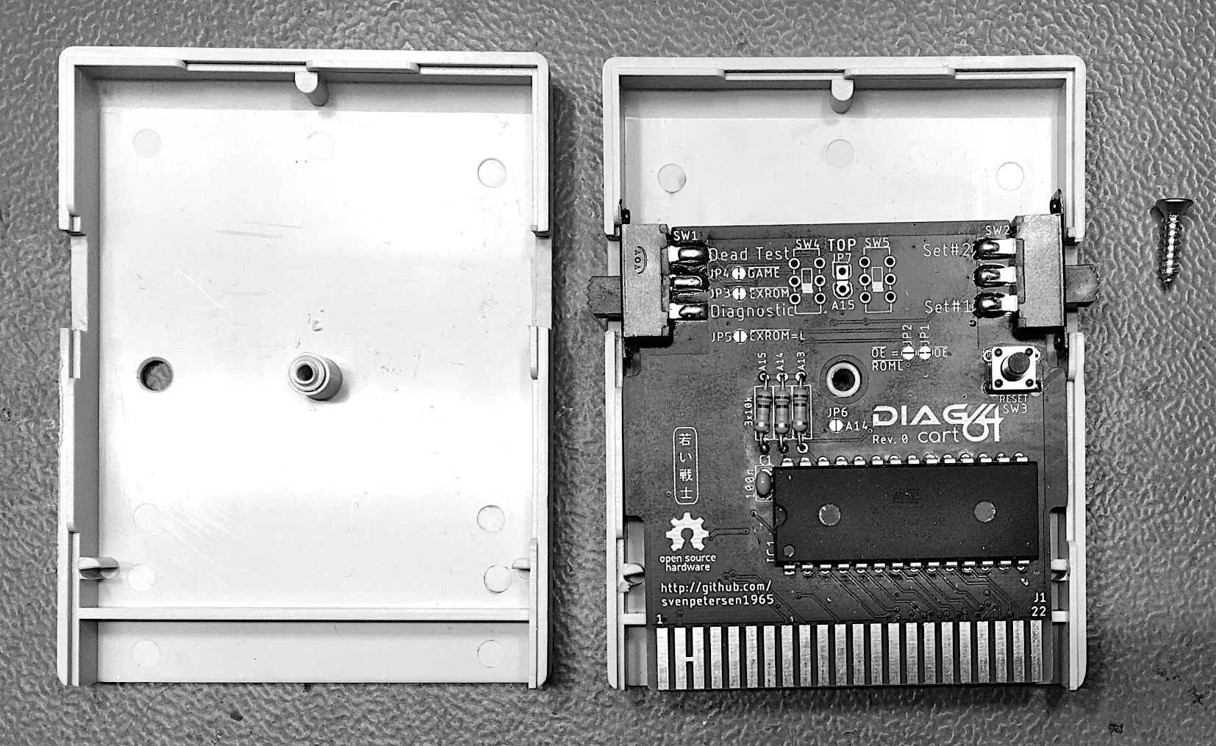

Figure 3: Diag64cart in the finished KM-20 case

# Suggested Software

This cartridge is made for C64 (and C128) Diagnostic software. So, the selection of suggested software is for this kind of purpose.

1. (Commodore) Diagnostic Rev. 586220 (C64) (Version +0.5)
2. (Commodore) Dead Test Rev. 781220 (C64)
3. STID Dead Test (v1.2.0)
4. (Commodore) Diagnostic Rev. 785260 (C128)
5. (Commodore) Diagnostic Rev. 588121 (C128)
6. 1541 Diagnostic (World of Jani)
7. Diag 4.1.1.

**Diagnostic Rev. 586220** and **Diag. 4.1.1** work with the same diagnostic harness (<https://github.com/svenpetersen1965/C64-Diagnostic-Rev.-586220-Harness>). While Diagnostic Rev. 586220 is still the diagnostic tool of my choice, Diag 4.1.1 is a bit different and might be useful as a second instance.

**Dead Test Rev. 781220** is THE dead test program, that can reveal RAM problems without requiring a working display. The first-choice software to debug a black screen.

**STID Dead Test** is a modification of the Commodore Dead Test Rev. 781220 it has some nice new features (e.g. tests the SID filters). It can be obtained here: <https://github.com/stid/kick-c64-dead-test>. The binary files can be found in the releases of this project. No compiling and building required.

The **1541 Diagnostics** is a very nice toolkit for testing and debugging a Commodore 1541 (or Oceanic OC-118) disk drive. It can be obtained here: <http://blog.worldofjani.com/?p=2180>

I have downloaded all other binaries from World of Jani: <http://blog.worldofjani.com/?p=164>

# Revision History

## Rev. 0

* Fully functional prototype